**INTRODUCTION**

### Overview: Chatbot To Shop For Essentials During Pandemic Using Watson Assistant

Category: IBM Cloud Application

Skills Required: ChatBot,IBM Watson Assistant,IBM Nodered

**Purpose**

Today, because of social distancing and other issues it can be risky for some people to shop for essential items in person. This project helps with this issue by giving people an online option to shop for essentials. With the help of Watson assistant, a chatbot is built. This chat should have the following capabilities:

1. Give the list of items in the Store
2. Should show the  prices of vegetables
3. Display if there are any offers or discounts
4. The bot should be able to take details like name, contact number, address, and the items to place the order.

**Services Used:**

1. IBM Watson Assistant
2. Node-Red

### Pre-Requisites

To complete this project you need to have an IBM cloud account. You can create this account

### Building Chatbot

In this milestone, we will be building a chatbot using Watson assistant.

### Login In To IBM Account

Duration: 0.5 Hrs

Skill Tags: PYB

In this activity we first login to IBM account

### Create Watson Assistant Service

Duration: 0.5 Hrs

Skill Tags: WAS

In this activity, we create Watson assistant service by going to the catalog. If you have already an existing Watson assistant then according to the lite plan of the IBM account you can create 5 skills(chatbots).

### Create Intents

Duration: 1 Hrs

Skill Tags: WAS

Create intents for the movie ticket booking chatbot, You can add the following intents:

1. Greetings
2. Enquiry about products
3. Placing order
4. COVID Q&A

By adding intents make sure that the scope of the chatbot is met.

### Create Entities

Duration: 0.5 Hrs

Skill Tags: WAS

In this activity, you need to create entities that include all the keywords that are present in the respective intents. Create multiple entities according to the requirement of the chatbot. Examples like @order @enquiry @items etc

### Use System Entities

Duration: 0.5 Hrs

Skill Tags: WAS

While building this chatbot you can make use of system entities that can be used to detect numbers that are useful while extracting information like Quantity, Phone number, etc.

### Create Dialog

Duration: 2 Hrs

Skill Tags: WAS

In this activity, we will be using Dialog in the Watson assistant to respond to the user.

In this chatbot add nodes for Greetings, inquiry, order items. In ordering items, you can make use of slots.

Make sure to delete context variables to make the chatbot reusable to other users.

Try to extract email id from the user by using patterns in entities.

### Create Node-Red Service

Duration: 0.5 Hrs

Skill Tags: WAS

Firstly to use node-red we need to create node-red service by going to the catalog.If you already have node-red service in your IBM cloud You can directly go to node-red from your dashboard by going to cloud foundry apps.

Duration: 0.5 Hrs

Skill Tags: WAS

In this activity, you will be integrating node-red to Watson assistant by using an assistant node in node-red.

* Firstly configure the assistant node by giving API key and service endpoint which you get from the skill that was created in Watson assistant.
* Next, install the dashboard nodes from the manage palette and create UI accordingly by making use of form nodes and text nodes.

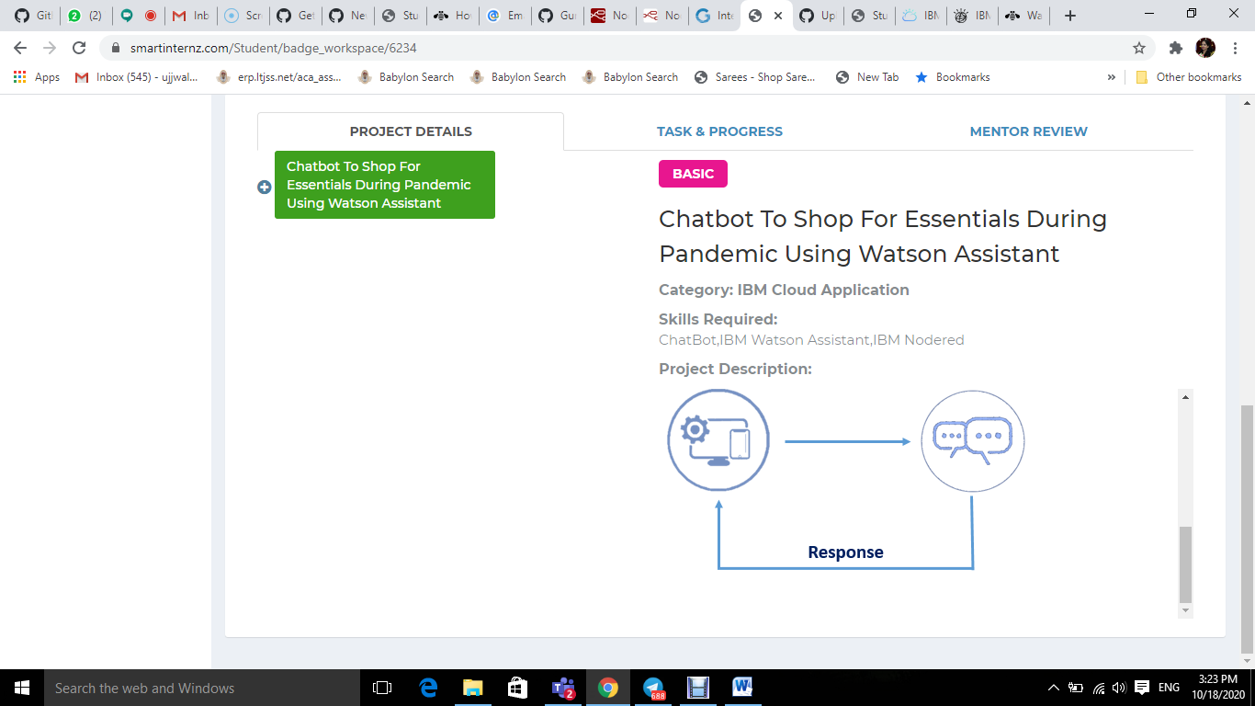

|  |  |  |  |  |  |  |  |
| --- | --- | --- | --- | --- | --- | --- | --- |
| **1** | |  | **INTRODUCTION** | |  |  |  |
|  | |  | * 1. Overview | |  |  |  |
|  | |  | 1.2 Purpose | |  |  |  |
| **2** | |  | **LITERATURE SURVEY** | |  |  |  |
|  | |  | 2.1 Existing problem | | |  |  |
|  | |  | 2.2 Proposed solution | | |  |  |
| **3** | |  | **THEORITICAL ANALYSIS** | |  |  |  |
|  | |  | 3.1 Block diagram | |  |  |  |
|  | |  | 3.2 Hardware / Software designing | | |  |  |
| **4** | |  | **EXPERIMENTAL INVESTIGATIONS** | | |  |  |
| **5** | |  | **FLOWCHART** | |  |  |  |
| **6** | |  | **RESULT** |  |  |  |  |
| **7** | |  | **ADVANTAGES & DISADVANTAGES** | | |  |  |
| **8** | |  | **APPLICATIONS** | |  |  |  |
| **9** | |  | **CONCLUSION** | |  |  |  |
| **10** | |  | **FUTURE SCOPE** | | **`** |  |  |
| **11** | |  | **BIBILOGRAPHY** | |  |  |  |
|  | |  | **APPENDIX** | |  |  |  |
|  |  | | A. Source code | |  |  |  |
|  |  | |  |  |  |  |  |
| **1** | |  | **INTRODUCTION** | |  |  |  |
|  | |  | * 1. Overview | |  |  |  |
|  | |  | 1.2 Purpose | |  |  |  |
| **2** | |  | **LITERATURE SURVEY** | |  |  |  |
|  | |  | 2.1 Existing problem | | |  |  |
|  | |  | 2.2 Proposed solution | | |  |  |
| **3** | |  | **THEORITICAL ANALYSIS** | |  |  |  |
|  | |  | 3.1 Block diagram | |  |  |  |
|  | |  | 3.2 Hardware / Software designing | | |  |  |
| **4** | |  | **EXPERIMENTAL INVESTIGATIONS** | | |  |  |
| **5** | |  | **FLOWCHART** | |  |  |  |
| **6** | |  | **RESULT** |  |  |  |  |
| **7** | |  | **ADVANTAGES & DISADVANTAGES** | | |  |  |
| **8** | |  | **APPLICATIONS** | |  |  |  |
| **9** | |  | **CONCLUSION** | |  |  |  |
| **10** | |  | **FUTURE SCOPE** | | **`** |  |  |
| **11** | |  | **BIBILOGRAPHY** | |  |  |  |
|  | |  | **APPENDIX** | |  |  |  |
|  |  | | A. Source code | |  |  |  |
|  |  | |  |  |  |  |  |